IFT 166 Introduction to Internet Networking
Lab 14
Understanding the importance of Default Gateways
Co-authored by James Copsey

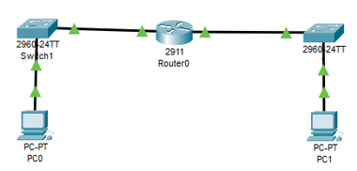
- Set up the following topology in packet tracer.

Completed
- Configure PC0 as shown below
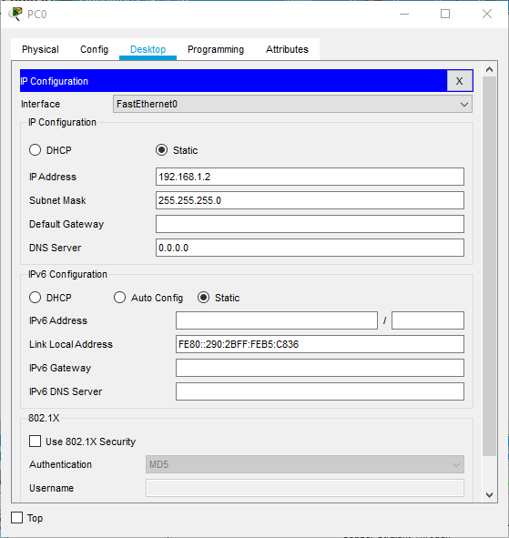

Completed

- Repeat the previous step for PC1 giving it a different IP address so it is assigned to the 19.168.2.0
Completed
- Now assign IP addresses to both GigabitEthernet0/0 interfaces on the router. You can the use GUI or the command line.
Completed
- Attempt to ping PC1 from PC0.
What happened? | The request times out. the ping fails
Why didn’t the pin work? | The ping did not work as there is no default gateway therefore no way to contact with other networks
- On PC0, enter in the default gateway as the IP address you set for GigabitEthernet0/0.
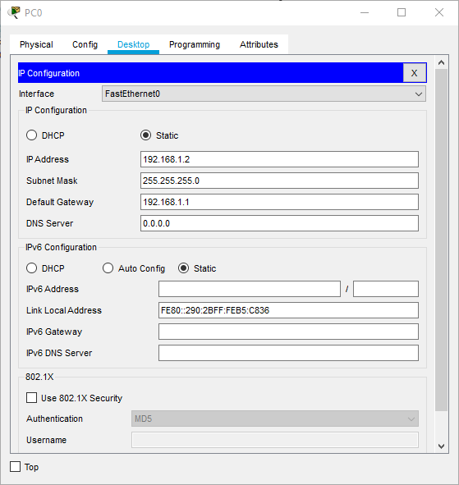
Completed
- Repeat the same step for PC1 and GigabitEthernet0/1, that you did for PC0 in step
Completed
- Attempt to ping PC1 from PC0 again.
Did it work?
It should be a “yes”
If not……..start troubleshooting
- Submit a screenshot of your successful ping in addition to this file.

